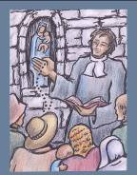
11. EVENT: Mission in Montbernage;
the Rosary entrusted to Jacques Goudeau.
● Date : 1705
● Place : Poitiers, chapel of Mary Queen of All Hearts
● Value : Rediscovering the value of the Rosary, and renewing it.
● The Story :
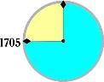
The mission in Montbernage was to close with farewells. Montfort entrusted his children to the Blessed Virgin: he renamed the barn of the Bergerie, Our Lady Queen of Hearts. “If someone,” he added, “is willing to recite here that prayer known as the Rosary, on Sundays and feast days, and to chant the Little Crown at midday, I will leave to that person the image of my good Mother.” A workman, Jacques Goudeau, offered to fill this role, and Father de Montfort, with joy, made him a gift of the statue that is invoked under the name of Mary, Queen of All Hearts.
The missionary could now leave without any worries. It has been reported that he was dissuaded from building a church dedicated to the Holy Spirit in Montbernage; but henceforth the district would possess his place of prayer, Our Lady, Queen of Hearts, which would be a centre of Christian life. Since that time, this shrine has always been venerated. In 1734, M. Devaucelle, the parish-priest of Sainte-Radegonde, solemnly blessed “on the orders of Mgr Jean-Claude de la Poype de Vertrieu…the chapel in Montbernage, under the patronage of the Blessed Virgin, erected by the late Messire Louis-Marie Grignion de Montfort, a great missionary, who died in the odour of sanctity at Saint-Laurent-sur-Sèvre in the diocese of La Rochelle, the said chapel of our district being called Our Lady of Hearts”. In the written record of these proceedings, next to the signature of M. Devaucelle, we find that of Jacques Goudeau. Faithful to his promise, this man was to preside for another forty years over the recitation of the Rosary. (Le Crom, pages 138-139)
● From Montfort’s Writings: (The Admirable Secret of the Rosary, 9)
The Rosary is made up of two things: mental prayer and vocal prayer. In the Rosary mental prayer is none other than meditation of the chief mysteries of the life, death and glory of Jesus Christ and of his blessed Mother. Vocal prayer consists in saying fifteen decades of the Hail Mary, each decade headed by an Our Father, while at the same time meditating on and contemplating the fifteen principal virtues which Jesus and Mary practised in the fifteen mysteries of the Rosary. (...) Thus, the Rosary is a blessed blending of mental and vocal prayer intended at honouring and imitating the mysteries and the virtues of the life, death, passion and glory of Jesus and Mary.
● Light from the Bible: (Luke 2:16-19)
The shepherds hurried away and found Mary and Joseph, and the baby lying in the manger. When they saw the child they repeated what they had been told about him, and everyone who heard it was astonished at what the shepherds said to them. As for Mary, she treasured all these things and pondered them in her heart.
(Acts 1:12-14)
So from the Mount of Olives, as it is called, the Apostles went back to Jerusalem, a short distance away, no more than a Sabbath walk; and when they reached the city they went to the upper room where they were staying; there were Peter and John, James and Andrew, Philip and Thomas, Bartholomew and Matthew, James son of Alphaeus and Simon the Zealot, and Jude son of James. With one heart all these joined constantly in prayer, together with some women, including Mary the mother of Jesus.
● Personal integration/sharing
- Is the Rosary a form of prayer that I use today?
- If I still say the Rosary, why have I kept to it?
- If I do not say it anymore, why did I abandon it?
- How might we avoid routine in the prayer of the Rosary?
- In my own experience, what is the great merit of the Rosary?
● Prayer/Celebration
- Mary, guide us in the paths of your prayer and contemplation.
Draw us in your ways.
- Mary, teach us to contemplate Christ, that we might become Christ.
Draw us in your ways.
- Mary, remove from us the noise and chattering that distract us from what is essential.
Draw us in your ways.
- O Mary, obtain for us from the Holy Spirit a deep taste for prayer.
Draw us in your ways.
- O Mary, may our prayer in common bring us closer to one another.
Draw us in your ways.
● Symbol: Rosary beads
● Commitment:
I read a book presenting the Rosary, The Admirable Secret of the Rosary by Montfort, or the letter of Pope John Paul II on the Rosary (Rosarium Virginis Mariae, 16 October 2002)
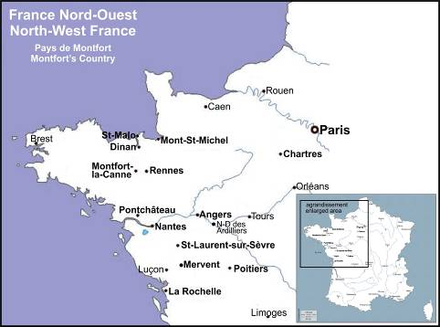
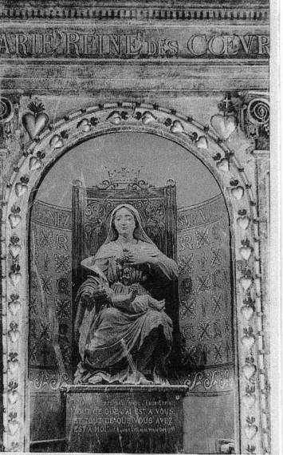
The original statue of Our Lady Queen of all Hearts,
in the suburb of Montbernage, Poitiers

