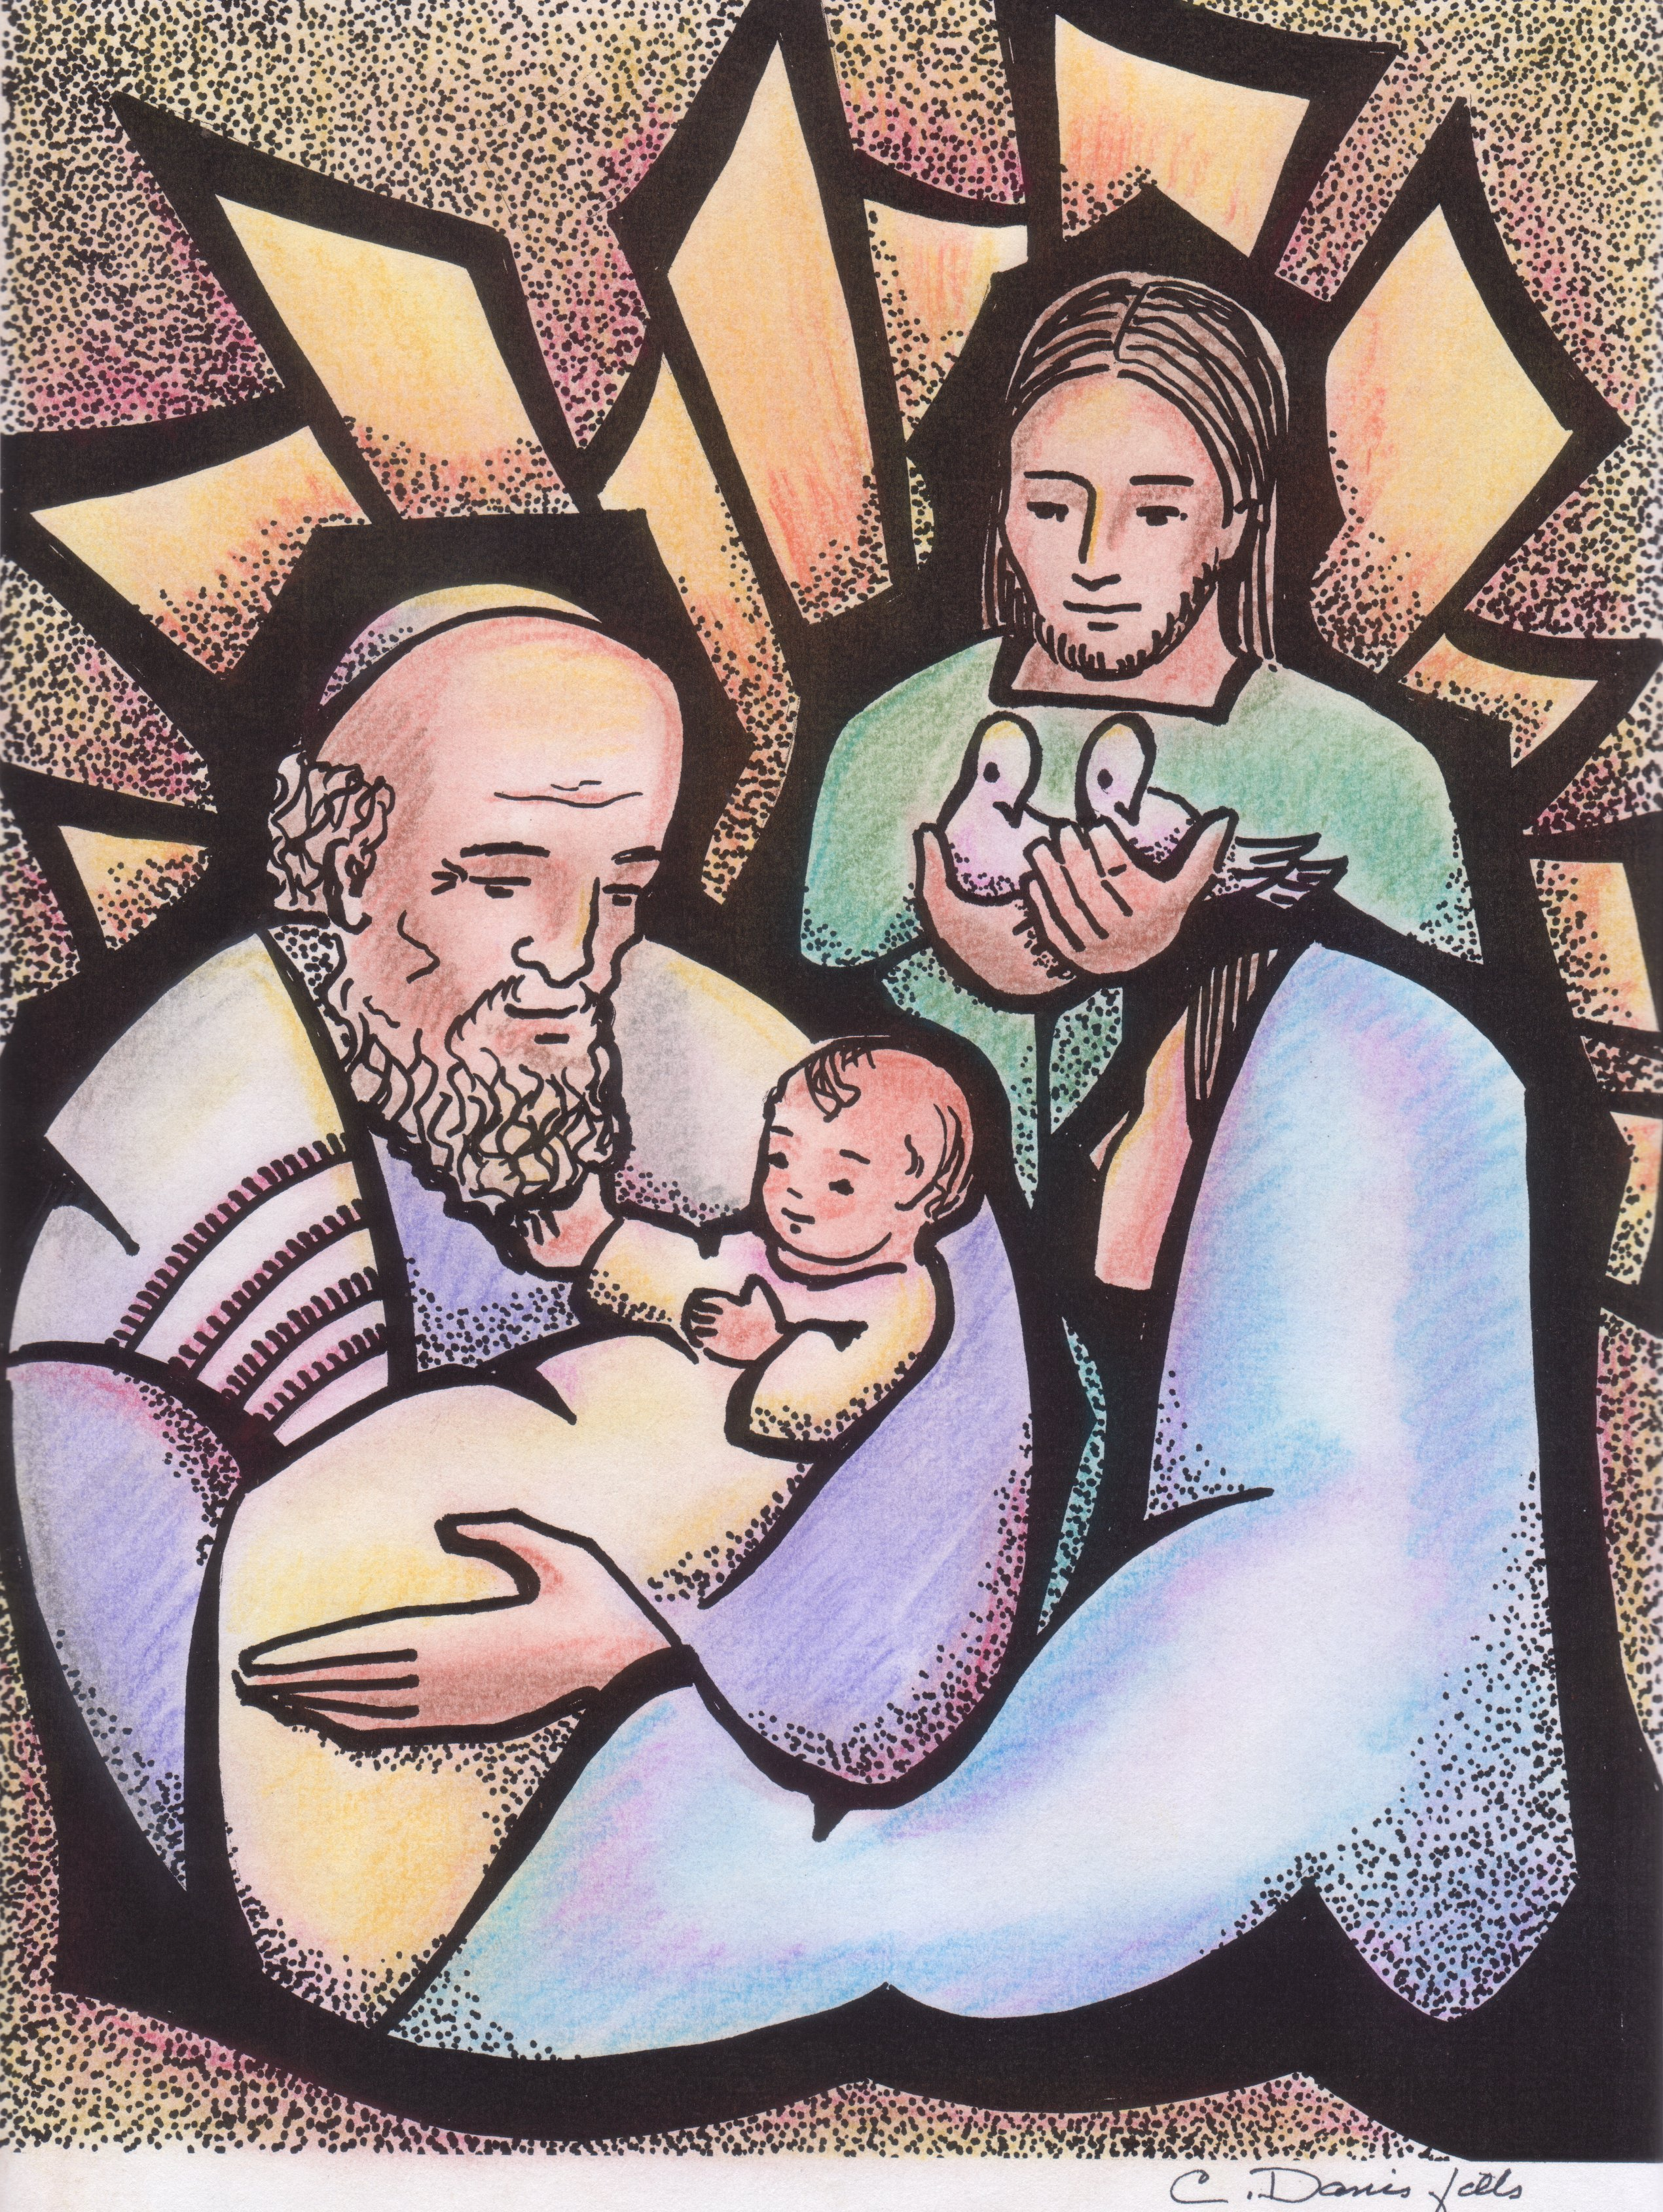
2 February 2017
Presentation of the Lord

3rd Celebration for the Preparation of the 2017 Chapter

Word of Introduction
Dear confreres, welcome to this celebration in preparation of our General Chapter. In the Orthodox tradition, the feast of the Presentation of the Lord is called «the feast of encounter» (hùpapantè): encounter of the Lord with His people represented by Simeon and Anna. Christ’s coming is symbolised by light, since he is «a light to enlighten the nations». Finally, the number 40 is a biblical symbol of journeying and progress, like that of the Israelites in the desert, of Jesus’ forty-day fast and of his appearances to the disciples after his resurrection. Through these symbols, we will celebrate our journey as Montfortians in to-day’s world and towards our General Chapter. Our celebration is composed of three elements:
1. Welcoming the light of Christ
2. Walking in the light of Christ
3. Spreading the light of Christ.

Entrance Hymn
† While the hymn is sung, two people enter in procession. The first one puts a lighted candle on the altar or on a table, and the other one puts an icon of Christ in front of or besides the candle.

(Christ be our light, 1-2)

1. Longing for light, we wait in darkness
Longing for truth, we turn to you.
Make us your own, your holy people,
Light for the world to see.

R. Christ, be our light! Shine in our hearts,
Shine through the darkness.
Christ, be our light!
Shine in your church gathered today.

2. Longing for peace, our world is troubled,
Longing for hope, many despair.
Your word alone has pow'r to save us.
Make us your living voice.

R. Christ, be our light! Shine in our hearts,
Shine through the darkness.
Christ, be our light!
Shine in your church gathered today.

1. WELCOMING THE LIGHT OF CHRIST
The word of God
A reading from the book of Genesis (1:1-5)
In the beginning God created heaven and earth. Now the earth was a formless void, there was darkness over the deep, with a divine wind sweeping over the waters. God said, 'Let there be light,' and there was light. God saw that light was good, and God divided light from darkness. God called light 'day', and darkness he called 'night'. Evening came and morning came: the first day.

R. Christ, be our light! Shine in our hearts,
Shine through the darkness.
Christ, be our light!
Shine in your church gathered today.

A reading from the Gospel of John
In the beginning was the Word: the Word was with God and the Word was God. Through him all things came into being. In him was life, and life was the light of men; and light shines in darkness.

R. Christ, be our light! Shine in our hearts,
Shine through the darkness.
Christ, be our light!
Shine in your church gathered today.

Listening to Montfort
From The Love of Eternal Wisdom
Eternal Wisdom began to manifest himself outside the bosom of God the Father when, after a whole eternity, he made light, heaven and earth. Saint John tells us that everything was made through the Word, that is eternal Wisdom. Solomon says that eternal Wisdom is the mother and maker of all things. Notice that Solomon does not call him simply the maker of the universe but also its mother because the maker does not love and care for the work of his hands like a mother does for her child. After creating all things, eternal Wisdom abides in them to contain, maintain and renew them. (Nos 31-32).

Prayer
Word of God, born of the Father from all eternity, we adore you.
Word of God, born of the Father from all eternity, we adore you.

Eternal Wisdom, through whom all was created, we adore you.
Eternal Wisdom, through whom all was created, we adore you.

Eternal Wisdom who took flesh from the flesh of the Virgin Mary, we adore you.
Eternal Wisdom who took flesh from the flesh of the Virgin Mary, we adore you.

Generous Light who came into our darkness, we adore you.
Generous Light who came into our darkness, we adore you.

Sun of justice, who guides us in the path of peace, we adore you.
Sun of justice, who guides us in the path of peace, we adore you.

Silent prayer (1'30")
† 1.5 minute of silent prayer. During that time, an extract from the Taizé chant «Nunc dimittis» can be played.

2. WALKING IN THE LIGHT OF CHRIST

The Word of God
We will now hear a passage from the New Testament rarely proclaimed in the liturgy. As we listen to it, let us imagine that Montfort is speaking to each one of us...

A reading from the third letter of John the Apostle (1-8)
My dear friend, concerning all things I pray that you prosper and be healthy, just as your soul prospers. For I rejoiced greatly when the brothers came and witnessed to the truth which is in you, just as you walk in the light of truth. I have no greater joy than this, that I hear that my children are walking in the light of truth. My friend, you do faithfully when you work for the brothers and for the strangers. They gave testimony concerning your love before the church, and it would be a kindness if you could help them in their mission as God would approve. It was entirely for the sake of the name that they set out: it is our duty to welcome people of this sort and contribute our share to their work for the truth. Peace be with you.

Prayer
For the times we walked away from you, Lord, forgive us
Lord forgive us.

For the times our habits kept us from walking towards you, Lord, forgive us.
Lord, forgive us.

For the times we let fear paralyse us, Lord, forgive us.
Lord, forgive us.

For the times that we did not encourage and support confreres in their walk towards you, Lord forgive us.
Lord, forgive us.

3. SPREADING THE LIGHT OF CHRIST
† A statuette of Montfort is placed near the candle. During this time, the refrain is sung.

R. Christ, be our light! Shine in our hearts,
Shine through the darkness.
Christ, be our light!
Shine in your church gathered today.

We are sent in the footsteps of the Apostles and of Montfort to spread the light of Christ. Our General Chapter will deliberate about our mission as Montfortian Missionaries in the Church and the world of to-day. Let us go back now to the source of our charism by listening to an extract of the conversation that Montfort had with his long time friend Jean-Baptiste Blain. It took place in Rouen in the fall of 1714.
Blain criticized him for having such a singular behaviour that it brought him problems and frightened possible candidates away from him. Here’s Montfort’s answer to that.

He said moreover that there are different kinds as there are different degrees of wisdom; that the wisdom of a person living in community is one thing, the wisdom of a missionary and an apostolic man quite another. (...) He went on to observe that the persons whom I had proposed to him as models of wisdom were of the first kind, men who remained hidden in their houses, which they governed in peace, because they had nothing new to establish, and nothing to do but to follow the footsteps and customs of those who had gone before them; but that it was not the same with missionaries and apostolic men. As they have always something new to take in hand, (...) it is impossible that they should not attract attention, and meet the approval of all around them; and finally, that, if wisdom consisted in doing nothing new for God, in undertaking nothing for his glory for fear of being spoken about, then the Apostles were wrong in leaving Jerusalem; they should have remained shut up in the upper room; St Paul should not have made so many journeys, or Saint Peter have attempted to plant the Cross upon the Capitol and conquer for Jesus Christ the queen city of the world; and the world would be still at the present day what it was then, idolatrous, perverted, corrupt in its morals and its maxims. (J-B Blain: Summary of the Life of L-M Grignion de Montfort Nos 335-337)

† A short time of silence can follow, during which the extract of the Taizé chant «Nunc dimittis» is played again.

Prayer
Now, with our confreres living in all five continents, let us pray the Lord that He help us enter more deeply into his light during this year of the General Chapter.

Let us pray for the Montfortians living throughout the world, that they prepare themselves for the Chapter through prayer and reflection
Lord, remember your congregation.

Let us pray for our General Council, our coach Fr Lavigne and all those involved in the preparation of the General Chapter
Lord, remember your congregation.

Let us pray for our lay associates, that this capitular year help us in welcoming and accompanying them better.
Lord, remember your congregation.

Let us pray for our postulants, our novices and confreres of temporary vows, that a deeper commitment to Montfort in the congregation inspire them to walk in his footsteps.
Lord, remember your congregation.

Let us pray for the new team that will be chosen to be in charge of the congregation, that they be animated by Montfort’s love for Christ and by his evangelical boldness.
Lord, remember your congregation.

Prayer for the General chapter
Father,
Remember your Congregation
at this time of our General Chapter.
You inspired Saint Louis Marie
to undertake the apostolic mission
of preaching the Gospel of Christ your Son to all people.
Aided by his prayers and taught by the Virgin Mary,
grant that we may be more and more open
to the inspiration of your Spirit,
attentive to the cries of the poor,
and so become untiring messengers of your Reign.
We make our prayer through our Lord Jesus Christ your Son,
who lives and reigns with you and the Holy Spirit,
one God, forever and ever. Amen.

Recessional hymn (Christ be our light, 4-5)

4. Longing for shelter, many are homeless,
Longing for warmth, many are cold.
Make us your building, sheltering others,
walls made of living stone.

R. Christ, be our light! Shine in our hearts,
Shine through the darkness.
Christ, be our light!
Shine in your church gathered today.

5. Many the gifts, many the people,
many the hearts that yearn to belong.
Let us be servants to one another,
making your kingdom come.

R. Christ, be our light! Shine in our hearts,
Shine through the darkness.
Christ, be our light!
Shine in your church gathered today.

The hymns suggested for the celebration are available on the website www.montfortian.info/chapitre-2017.html

